- a) i) Explain why the two dimensional Discrete Cosine Transform is separable. [2]
ii) Show that the two dimensional Discrete Cosine Transform can be implemented using the one dimensional Discrete Cosine Transform. [2]

- Let $f(x,y)$ denote an $M×N$-point 2-D sequence that is zero outside $0≤x≤M−1$, $0≤y≤N−1$, where $M$ and $N$ are integers and powers of 2. In implementing the standard Discrete Walsh Transform of $f(x,y)$, we relate $f(x,y)$ to a new $M×N$-point sequence $W(u,v)$.
- Define the sequence $W(u,v)$ in terms of $f(x,y)$. [2]
- State the advantages of the Discrete Walsh Transform. [2]
- In the case of $M=N=2$ and $f(x,y)=\left[\begin{matrix}1 & 2 \\ 2 & 3\end{matrix}\right]$ calculate the Walsh transform coefficients.
[2]

c) Consider the population of vectors $\underline{f}$ of the form
$\underline{f}(x,y)=\left[\begin{matrix}f_{1}(x,y) \\ f_{2}(x,y)\end{matrix}\right]$.
Each component $f_{i}(x,y), i=1,2$ represents an image of size $M×M$ where $M$ is even. The population arises from the formation of the vectors across the entire collection of pixels $(x,y)$.
The two images are defined as follows:
$$f_{1}(x,y)=\left\{\begin{matrix}r_{1} & 1≤x≤\frac{M}{4},1≤y≤M \\ r_{2} & \frac{M}{4}<x≤M,1≤y≤M\end{matrix}\right.$$
$$f_{2}(x,y)=r_{3}, 1≤x≤M, 1≤y≤M$$
Consider now a population of random vectors of the form
$$\underline{g}(x,y)=\left[\begin{matrix}g_{1}(x,y) \\ g_{2}(x,y)\end{matrix}\right]$$
where the vectors $\underline{g}$ are the Karhunen-Loeve (KL) transforms of the vectors $\underline{f}$.
i) Find the images $g_{1}(x,y)$ and $g_{2}(x,y)$ using the Karhunen-Loeve (KL) transform. [8]
ii) Comment on whether you could obtain the result of c)-i) above using intuition rather than by explicit calculation.
[2]

2. a) The probability density functions of two grey level images $f(x,y)$ and $g(x,y)$ with intensities $r$ and $s$ respectively, are illustrated in Figure 2a below. For each image $f(x,y)$ and $g(x,y)$ find and sketch the transformation function that produces a histogram equalised image.
[5]
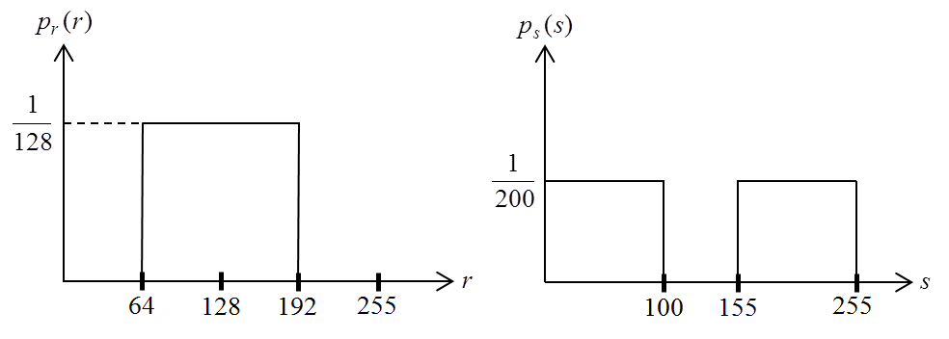
Figure 2a

b) Suppose that a grey level image with intensity $r$ has the probability density function shown on the left in Figure 2b below. We would like to modify the image intensities so that the new image has the probability density function given on the right of Figure 2b. Derive a transformation function that will accomplish this.
[5]
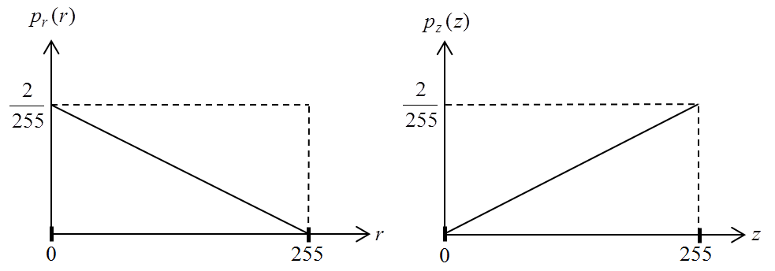
Figure 2b

c) State which one of the following filters is nonlinear: High Boost Filter, Weighted Averaging Filter, Sobel Filter, Median Filter. Justify your answer with an example.
[5]

d) Explain which one of the following filters is commonly used for sharpening images: Averaging Filter, Differentiation Filter, Weighted Averaging Filter, Median Filter.
[5]

3. a) We are given the degraded version $g$ of an image $f$ such that in lexicographic ordering
$$g=\text{Hf}+n$$
where $H$ is the degradation matrix which is assumed to be block-circulant, and $n$ is the noise term which is assumed to be zero mean, white and independent of the image $f$. The images have size $N×N$.
i) Consider the Wiener Filtering image restoration technique. Prove the general expressions for both the Wiener filter estimator and the restored image in both spatial and frequency domains and explain all symbols used. [10]

ii) Discuss the disadvantages of the Wiener Filtering image restoration technique. [5]

b) In a particular scenario, the image under consideration is degraded by a transfer function which, in the frequency domain, is given by the function below:
$$H(u,v)=\sqrt{2π}σ(u^{2}+v^{2})e^{−2π^{2}σ^{2}(u^{2}+v^{2})}$$
In the above formulation $σ$ is a constant parameter. Generate the expression of the Wiener filter by assuming that the ratio of power spectra of the noise and un-degraded image is constant.
[5]

4. a) i) Name three reasons why it might be a good idea to compress data. [2] [2]

ii) Discuss the characteristics of the histogram that an image must possess in order to be amenable to compression using a Huffman code. [2]

iii) Consider the $8×8$ image $f(x,y),x,y=0,…,7$ shown in Figure 4a below. The top left corner is the point $(x,y)=(0,0)$ and $x$ is the horizontal dimension. Explain how differential coding can be used to compress this image if the prediction formula is $f(x,y)−f(x+1,y)$for $x<7$ and 0 for $x=7$.

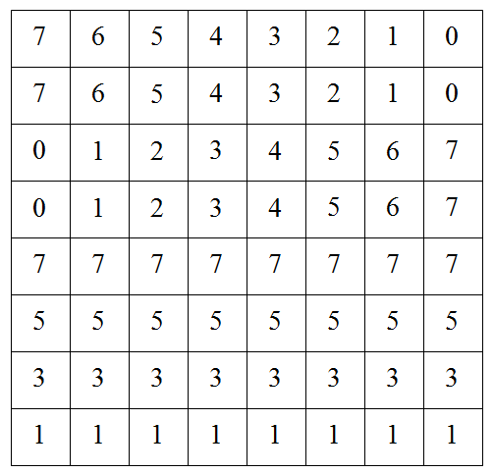

Figure 4a
[4]

b) The following Figure 4b shows a $5×5$ image with 5 different grey levels with values shown on the right figure.
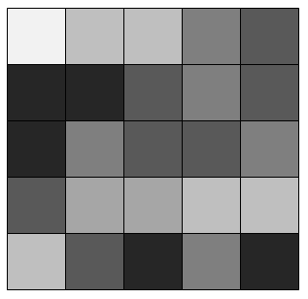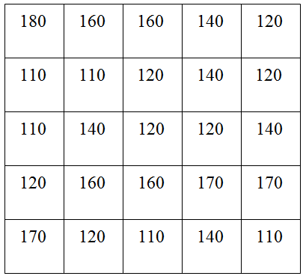

Figure 4b

i) Derive the probability of appearance (that forms the histogram) for each intensity (grey) level. Calculate the entropy of this image. [3] [2]
ii) Derive a Huffman code. [3] [2]
iii) Calculate the average length of the fixed length code and that of the derived Huffman code. [3]
iv) Calculate the compression ratio and the relative coding redundancy. [3]

- a) i) Bookwork
- Bookwork

b) i) Bookwork
ii) 1. A large fraction of the signal energy is packed within very few transform coefficients, the ones near the origin. By keeping the low index transform coefficients and replacing the rest with zero we can achieve image compression. 2. Basis functions consist of 1s and -1s and therefore the transform is more resistant to errors.
- We know that $N=2^{n}$ and therefore, in case of $N=2$ we have $n=1$, $x,y$ 0 or 1 and $b_{0}(0)=b_{0}(0)=0$ and $b_{0}(1)=b_{0}(1)=1$. For $f(x,y)=\left[\begin{matrix}1 & 2 \\ 2 & 3\end{matrix}\right]$ we calculate the Walsh transform coefficients as follows.

$$W(u,v)=\frac{1}{N}\sum_{x=0}^{2−1}{\sum_{y=0}^{2−1}{f}(x,y)\left[\prod_{i=0}^{n−1}{(−1)^{(b_{i}(x)b_{n−1−i}(u)+b_{i}(y)b_{n−1−i}(v))}}\right]}$$
$$W(u,v)=\frac{1}{N}\sum_{x=0}^{1}{\sum_{y=0}^{1}{f}(x,y)\left[\prod_{i=0}^{1−1}{(−1)^{(b_{i}(x)b_{−i}(u)+b_{i}(y)b_{−i}(v))}}\right]}$$
$$W(u,v)=\frac{1}{N}\sum_{x=0}^{1}{\sum_{y=0}^{1}{f}(x,y)(−1)^{(b_{0}(x)b_{0}(u)+b_{0}(y)b_{0}(v))}}$$
$$\begin{aligned}=\frac{1}{2}f(0,0)(−1)^{(b_{0}(0)b_{0}(u)+b_{0}(0)b_{0}(v))}+\frac{1}{2}f(0,1)(−1)^{(b_{0}(0)b_{0}(u)+b_{0}(1)b_{0}(v))} \\ +\frac{1}{2}f(1,0)(−1)^{(b_{0}(1)b_{0}(u)+b_{0}(0)b_{0}(v))}+\frac{1}{2}f(1,1)(−1)^{(b_{0}(1)b_{0}(u)+b_{0}(1)b_{0}(v))}\end{aligned}$$
$$\begin{aligned}=\frac{1}{2}f(0,0)(−1)^{(0⋅b_{0}(u)+0⋅b_{0}(v))}+\frac{1}{2}f(0,1)(−1)^{(0⋅b_{0}(u)+1⋅b_{0}(v))} \\ +\frac{1}{2}f(1,0)(−1)^{(1⋅b_{0}(u)+0⋅b_{0}(v))}+\frac{1}{2}f(1,1)(−1)^{(1⋅b_{0}(u)+1⋅b_{0}(v))}\end{aligned}$$
$$=\frac{1}{2}f(0,0)(−1)^{0}+\frac{1}{2}f(0,1)(−1)^{b_{0}(v)}+\frac{1}{2}f(1,0)(−1)^{b_{0}(u)}+\frac{1}{2}f(1,1)(−1)^{b_{0}(u)+b_{0}(v)}$$
$$=\frac{1}{2}(−1)^{0}+\frac{1}{2}2(−1)^{b_{0}(v)}+\frac{1}{2}2(−1)^{b_{0}(u)}+\frac{1}{2}3(−1)^{b_{0}(u)+b_{0}(v)}$$
$$=\frac{1}{2}+(−1)^{b_{0}(v)}+(−1)^{b_{0}(u)}+\frac{3}{2}(−1)^{b_{0}(u)+b_{0}(v)}$$
$$W(0,0)=\frac{1}{2}+(−1)^{b_{0}(0)}+(−1)^{b_{0}(0)}+\frac{3}{2}(−1)^{b_{0}(0)+b_{0}(0)}=\frac{1}{2}+(−1)^{0}+(−1)^{0}+\frac{3}{2}(−1)^{0}=\frac{1}{2}+1+1+\frac{3}{2}=4$$
$$\begin{aligned}W(0,1)=\frac{1}{2}+(−1)^{b_{0}(0)}+(−1)^{b_{0}(1)}+\frac{3}{2}(−1)^{b_{0}(0)+b_{0}(1)}=\frac{1}{2}+(−1)^{0}+(−1)^{1}+\frac{3}{2}(−1)^{0+1} \\ =\frac{1}{2}+1−1−\frac{3}{2}=−1\end{aligned}$$
$$\begin{aligned}W(1,0)=\frac{1}{2}+(−1)^{b_{0}(1)}+(−1)^{b_{0}(0)}+\frac{3}{2}(−1)^{b_{0}(1)+b_{0}(0)}=\frac{1}{2}+(−1)^{1}+(−1)^{0}+\frac{3}{2}(−1)^{1+0} \\ =\frac{1}{2}−1+1−\frac{3}{2}=−1\end{aligned}$$
$$\begin{aligned}W(1,1)=\frac{1}{2}+(−1)^{b_{0}(1)}+(−1)^{b_{0}(1)}+\frac{3}{2}(−1)^{b_{0}(1)+b_{0}(1)}=\frac{1}{2}+(−1)^{1}+(−1)^{1}+\frac{3}{2}(−1)^{1+1} \\ =\frac{1}{2}−1−1+\frac{3}{2}=0\end{aligned}$$
Therefore, $W(u,v)=\left[\begin{matrix}4 & −1 \\ −1 & 0\end{matrix}\right]$.

c) i) $f_{1}(x,y)=\left\{\begin{matrix}r_{1} & 1≤x≤\frac{M}{4},1≤y≤M \\ r_{2} & \frac{M}{4}<x≤M,1≤y≤M\end{matrix}\right.$
Mean value of $f_{1}(x,y)$ is $m_{1}=\frac{r_{1}}{4}+\frac{3r_{2}}{4}$. Zero-mean version of $f_{1}(x,y)$ is
$$f_{1}(x,y)−m_{1}=\left\{\begin{matrix}\frac{3r_{1}}{4}−\frac{3r_{2}}{4} & 1≤x≤\frac{M}{4},1≤y≤M \\ \frac{r_{2}}{4}−\frac{r_{1}}{4} & \frac{M}{4}<x≤M,1≤y≤M\end{matrix}\right.$$
Mean value of $f_{2}(x,y)$ is $r_{3}$. Zero-mean version of $f_{2}(x,y)$ is $f_{2}(x,y)−m_{2}=0$.
Variance of $f_{1}(x,y)−m_{1}$ is $\frac{1}{4}\frac{9}{\text{16}}(r_{1}−r_{2})^{2}+\frac{3}{4}\frac{1}{\text{16}}(r_{1}−r_{2})^{2}=\frac{3}{\text{16}}(r_{1}−r_{2})^{2}$.
Variance of $f_{2}(x,y)−m_{2}$ is 0.
Covariance between $f_{1}(x,y)−m_{1}$ and $f_{2}(x,y)−m_{2}$ is 0. Therefore, the covariance matrix is $\left[\begin{matrix}\frac{3}{\text{16}}(r_{1}−r_{2})^{2} & 0 \\ 0 & 0\end{matrix}\right]$ with eigenvalues $\frac{3}{\text{16}}(r_{1}−r_{2})^{2}$ and 0. Therefore, by using the Karhunen Loeve transform we produce two new images, with one of them being 0 and the other being $f_{1}(x,y)−m_{1}$.
ii) The above result is expected since one of the given images is constant and therefore it doesn’t carry any information. This means that there is only one principal component in the given set.

- a) The transformation used for histogram equalisation is $s=T(r)=\int_{0}^{r}{p_{r}(w)\text{dw}}$. Based on that we get:
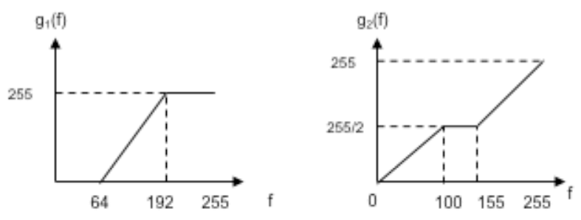
b)
should be between 0 and 255 and therefore

- Trivial. The answer is median. This can be demonstrated by simple example, i.e., median(0,1,0)+median(2,0,0)=0+0=0. This is not the same as the median of (2,1,0) which is 1.

d) Book work. The answer is differentiation filter.

3. a) i) Bookwork
ii) Bookwork

b)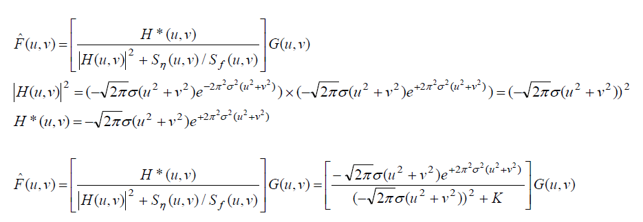

4. a) i) 1. To save disk space. 2. To decrease transmission time when transferring files over networks. 3. To make some programs work faster (e.g. by decreasing disk access time).
ii) It must deviate from uniform.
iii) After differential coding using the given formula, the resulting image has only 3 values 1,-1,0 and 0 dominates, therefore it is must more efficient to use differential coding. [4]

b) i)
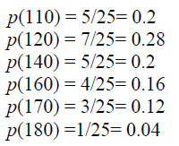
ii) Derive the Huffman code.

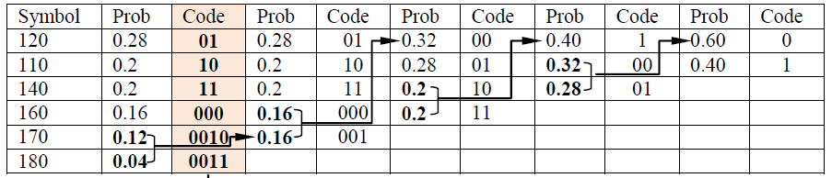
iii) Calculate the average length of the fixed code and that of the derived Huffman code.
Fixed length: 3 bits/symbol
Huffman: Lavg=2.48 bits/symbol

iv) Compression ratio 3/2.48
Redundancy=3-2.48

