- a) Consider an -pixel gray level image which is zero outside and . The image intensity is given by the following relationship
$$f(x,y)=\left\{\begin{matrix}c, & y=y_{0},0≤x≤M−1 \\ 0, & \text{otherwise}\end{matrix}\right.$$
where is a constant value between 0 and 255 and $y_{0}$ is a constant value between 0 and $N−1$.
- Plot the image intensity. [2]
- Find the -point Discrete Fourier Transform (DFT) of . Plot its amplitude response. [4]
- Compare the plots found in (i) and (ii) above. [2]

The following result holds: $\sum_{k=0}^{N−1}{a^{k}}=\frac{1−a^{N}}{1−a},\left|a\right|≤1$.

- Consider the image shown in Figure 1.1(a) below. Two plots of magnitude of Two-Dimensional Discrete Fourier Transform (2D DFT) are shown in Figure 1.1(b) and 1.1(c) below. Discuss which one is the magnitude of the 2D DFT of the image of Figure 1.1(a). Justify your answer. [4]

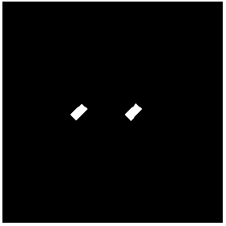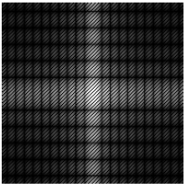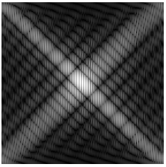
(a) (b) (c)
Figure 1.1

c) Consider the population of vectors $\underline{f}$ of the form
$\underline{f}=\left[\begin{matrix}f_{1}(x,y) \\ f_{2}(x,y)\end{matrix}\right]$.
Each component $f_{i}(x,y),i=1,2$ represents an image of size $M×M$, where $M$ is even. The population arises from their formation across the entire collection of pixels.
The two images are defined as follows:
$f_{1}(x,y)=\left\{\begin{matrix}r_{1} & 1≤x≤M,1≤y≤\frac{M}{2} \\ s_{1} & 1≤x≤M,\frac{M}{2}<y≤M\end{matrix}\right.$, $f_{2}(x,y)=\left\{\begin{matrix}r_{2} & 1≤y≤M,1≤x≤\frac{M}{2} \\ s_{2} & 1≤y≤M,\frac{M}{2}<x≤M\end{matrix}\right.$
Consider now a population of random vectors of the form
$$\underline{g}=\left[\begin{matrix}g_{1}(x,y) \\ g_{2}(x,y)\end{matrix}\right]$$
where the vectors $\underline{g}$ are the Karhunen-Loeve (KL) transforms of the vectors $\underline{f}$.
(i) Find the images $g_{1}(x,y)$ and $g_{2}(x,y)$ using the Karhunen-Loeve (KL) transform.
[4]
(ii) Comment on whether you could obtain the result of c)-(i) above using intuition. [4]
2. a) Consider the 3-grey-level digital image $f(x,y)$ of size $\text{256}×\text{256}$shown below in Figure 2.1, where $0≤x,y≤\text{255}$. The intensity of this image is constant and equal to $r_{1}$ for most of the pixel locations. Inside the image there is a pattern of two small rectangular areas. The smallest area is of intensity $r_{2}$ and occupies the pixels at locations $\text{144}≤x,y≤\text{175}$. This is placed within a slightly larger square area which occupies the pixels at locations $\text{128}≤x,y≤\text{191}$. The intensities of this area are $r_{3}$ everywhere apart from the locations that form the smallest square placed in the middle.

Figure 2.1

Intensities $r_{1},r_{2},r_{3}$ lie within 0 and 255, such that $r_{3}≤r_{2}≤r_{1}$ and $r_{2}=r_{3}+1$.
- Apply global histogram equalization to the image $f(x,y)$. Let $h_{\text{out}}(s)$ denote the resulting (equalized) histogram of pixel values $s$ taking values in [0, 255]. Sketch the plot of $h_{\text{out}}(s)$, and label the plot axes. Sketch the resulting histogram equalised image. [5]
- Apply local histogram equalization to the image $f(x,y)$ by diving the image in non-overlapping patches of size $\text{64}×\text{64}$. Sketch the resulting histogram equalised image.
[5]
(iii) Discuss which of the two transforms, i.e., the global or the local histogram equalization is more beneficial for the given image. [5]
[Note: the dark line that appears around the image is used to signify the boundary of the image, but is not part of it.]

b) The two images shown below in Figure 2.2 are quite different, but their histograms are identical. Both images have size 8 × 8, with black and white pixels. Suppose that both images are blurred with a 3×3 smoothing mask. Would the resultant histograms still be the same? Draw approximately the two histograms and explain your answer.
[Note: the dark lines that appear around the two images are used to signify the boundaries of the images but are not part of them.]

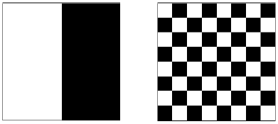

Figure 2.2

[5]
3. a) We are given the degraded version $g$ of an image $f$ such that in lexicographic ordering
$$g=\text{Hf}+n$$
where $H$ is the degradation matrix which is assumed to be block-circulant, and $n$ is the noise term which is assumed to be zero mean, independent and white. The images have size $N×N$ with $N$ even. In a particular scenario, the image under consideration is blurred to relative motion between the image and the camera. The pixel of the image $g$ at location $(x,y)$ is related to the corresponding pixel of image $f$ through the following relationship:
$$g(x,y)=f(x,y)+2f(x,y−1)+f(x,y−2)+n(x,y)$$

- Consider the Inverse Filtering image restoration technique. Find the expressions for both the Inverse filter estimator and the restored image in the frequency domain. [5]
- Find the specific frequencies for which the restored image cannot be estimated.
[5]
- Consider the Constrained Least Squares image restoration technique. The two dimensional high pass filtering operator used in the regularization term is given by the function below:
$$c(x,y)=\left\{\begin{matrix}1 & x=0,y=0 & \\ −2 & x=0,y=1 & \\ 1 & x=0,y=2 & \\ 0 & \text{elsewhere} & \end{matrix}\right.$$
Find the expressions for both the Constrained Least Squares filter estimator and the restored image in the frequency domain.
[5]
- Find whether there are any specific frequencies for which the restored image cannot be estimated.
[5]

4. a) Consider a grey level image $f(x,y)$ with grey levels from 0 to 255. Assume that the image $f(x,y)$ has medium contrast. Furthermore, assume that the image $f(x,y)$ contains large areas of slowly varying intensity. Consider the image
$g(x,y)=f(x,y)−0\text{.}5f(x−1,y)−0\text{.}5f(x,y−1)$.
(i) Sketch a possible histogram of the image $f(x,y)$. [2] [2]
(ii) Discuss the characteristics of the histogram of the image $g(x,y)$. [2]
(iii) Explain which of the two images is more amenable to compression using Huffman code. [2]
[4]
b) The following Figure 4.1 shows a $\text{10}×\text{10}$ image with 3 different grey levels (black, grey, white).
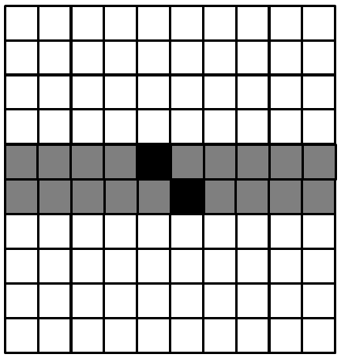
Figure 4.1

(i) Derive the probability of appearance (that forms the histogram) for each intensity (grey) level. Calculate the entropy of this image. [2] [2]
(ii) Derive the Huffman code. [2] [2]
(iii) Calculate the average length of the fixed length code and that of the derived Huffman code. [2]
(iv) Calculate the ratio of image size (in bits) between using the fixed length coding and Huffman coding. Calculate the relative coding redundancy. [2]
(v) Derive the extended-by-two Huffman code. [2]
(vi) Calculate the ratio of image size (in bits) between using the fixed length coding and extended Huffman coding. Calculate the relative coding redundancy. [2]
(vii) Comment on the efficiency of the extended Huffman code for this particular image. [2]

